
Complete Problem-Oriented Assessment and Plans Using Diagnosis-Aware Notes
Problem-oriented charting in Epic allows you to document an assessment and plan note for each hospital problem during an admission, throughout the patients stay, and at discharge. These A&P notes are saved with the problem and clinicians can view the history of the problem quickly by scanning the A&Ps.
You can now create these problem-specific A&P notes directly from your note using Diagnosis-Aware Notes, without having to open the problem list or disrupt your efficient note workflow. If you're familiar with the existing workflow in the problem list, you can still do that too.
When all clinicians who care for a patient complete documentation that files these A&P notes, anyone can review the course of the problem from a consolidated report.
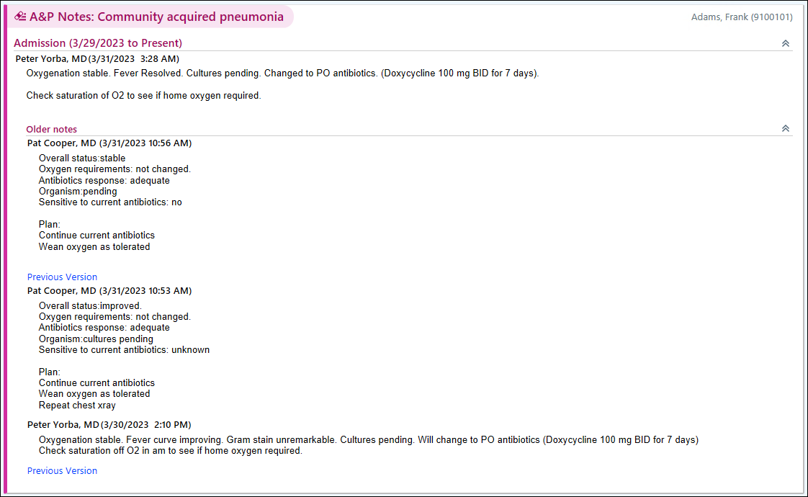

Try It Out
Create A&P notes for hospital problems directly in your progress note.
- Create your note and pull in your favorite note template.
- If the Assessment & Plan section doesn't automatically appear as shown below, type .DiagPOC to add it. This section includes all hospital problems. Under each problem, document your A&P. You can drag and drop problems to rearrange them in your note. Press F8 to move to the next problem in the section.
- Save your note. The A&P text now appears for each corresponding hospital problem on the problem list.
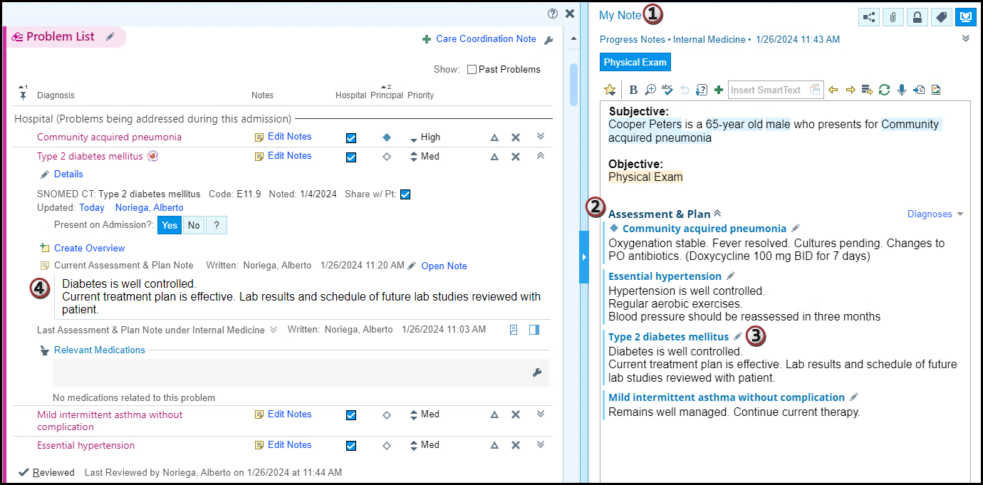

Choose Which Problems to Document On and Manage Problems
All hospital problems are pulled into the Diagnosis-Aware Note automatically, but you can remove any problems from your note. You can also add and remove hospital problems from the problem list directly from your note.
- Click Diagnoses.
- Clear the checkbox for any problems that you don't want to include in the note.
- To add a new hospital problem to the problem list, select Add Problem.
- To resolve a hospital problem on the problem list, in the main body of the note, right-click the problem or click the pencil icon next to it. In the menu that appears, select Resolve Problem or Resolve & Add to Hx to resolve and add it to medical history.
- To delete a hospital problem from the problem list, from the same menu in step 4, select Delete Problem. 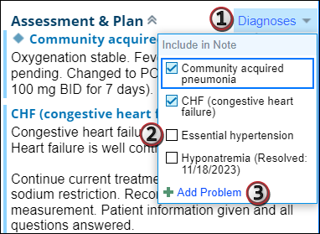

Review A&Ps for a Problem
You can see a history of the A&Ps for a problem in the problem list:
- Open the Problem List activity or navigator section and expand the problem you want to review.
- Click the View All Notes button to open a report with A&Ps written in chronological order.
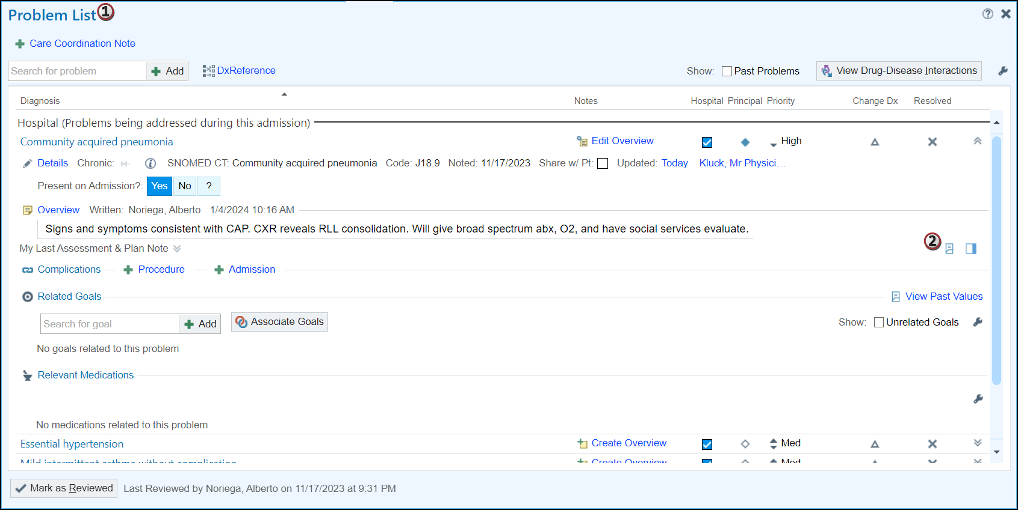

Additional Considerations
If you mark your note as sensitive, A&P notes are not filed to the problem list. The problem list provides all members of the care team with a shared view of information and no problems or pieces of information can be individually marked as sensitive. Therefore, when you create A&P documentation in a note marked as sensitive, that documentation appears only in that note.
In certain departments that frequently deal with sensitive topics, A&P notes might be disabled. If this is the case, the note documentation never files A&P notes to the problems to ensure that sensitive details are not inadvertently shared more broadly than you might expect.
You cannot use partial dictations with transcription within the A&P section for a hospital problem. You can use partial dictations for other parts of the note.

