

*Getting Started with*

CareSelect™ Imaging for Epic

**Welcome**

This guide serves as an introduction to the CareSelect Imaging for point-of-order clinical decision support for high-tech imaging studies. Catholic Health has implemented CareSelect Imaging with Epic for the following modalities and patient care settings:

|  |  |
| --- | --- |
| Modalities | Physician Groups |
| * CT, MRI, Nuclear Medicine | * All Ordering Providers |

What is CareSelect Imaging?

CareSelect Imaging is a qualified Clinical Decision Support Mechanism (qCDSM) that integrates directly within Epic. The CareSelect content relies on evidence-based criteria for the appropriate use of high-tech imaging studies from qualified provider-led entities (qPLEs) including the American College of Radiology (ACR), the National Comprehensive Cancer Network (NCCN), the American College of Cardiology (ACC), and the Society for Nuclear Medicine and Molecular Imaging (SNMMI). CareSelect Imaging is designed to reduce unnecessary imaging by providing guidance directly at the point of order.

Why CareSelect Imaging?

Clinical Decision Support (CDS) has been shown to improve the likelihood that the most useful test will be ordered at the first point of order entry, which improves the diagnostic accuracy, shortens time to diagnosis, and improves patient satisfaction.

Additionally, the Protecting Access to Medicare Act (PAMA) legislation requires all providers to consult a qCDSM for AUC when ordering advanced imaging studies for Medicare Part B patients. The new Reason for Exam question and its associated indications are being deployed in preparation for implementing PAMA-compliant CDS.

*Need Help? For questions, comments, and support, please contact:*

*Pamela Wishowski at* [*pamela.wishowski@chsbuffalo.org*](mailto:pamela.wishowski@chsbuffalo.org) *or Cheryl Nosal at* [*cnosal@chsbuffalo.org*](mailto:cnosal@chsbuffalo.org)*.*

**Information on the CareSelect Imaging Appropriateness Criteria Scoring**

As mentioned above, the CareSelect Imaging Appropriateness Criteria was created by expert panels using evidence and professional opinions. The American College of Radiology (ACR), the Society of Pediatric Radiology (SPR) and the Society of Nuclear Medicine and Molecular Imaging (SNMMI) prefer to give their scores numerically on a scale of 1 to 9, which is divided into three groups based on order and indication combination appropriateness: 1-3 (Usually Not Appropriate), 4-6 (May Be Appropriate), and 7-9 (Usually Appropriate). The American College of Cardiology (ACC) and National Comprehensive Cancer Network (NCCN) give their recommendations textually and are divided into the same three groups that can be equivocated numerically to the average of each numerical group.

The first category is “Usually Not Appropriate” (represented by the color red) which includes numerical scores of 1, 2, and 3, as well as the “Not Recommended” textual score (average numerical score of 2) used by ACC and NCCN. This category indicates that the harm of doing the procedure generally outweighs the benefits.

The second category is “May Be Appropriate” (represented by the color yellow) that includes numerical scores of 4, 5, and 6, as well as the “May Be Appropriate” textual score (average numerical score of 5) used by ACC and NCCN. This middle category is used when the risks and benefits are equal or unclear.

The third category is “Usually Appropriate” (represented by the color green) that includes numerical scores of 7, 8, and 9, as well as the “Recommended” textual score (average numerical score of 8) used by ACC and NCCN. This category indicates that the benefits of doing the procedure usually outweigh the harms or risks.

Some risks or benefits may vary due to specific patient information or scenarios. Because of this, the final decision made by the provider may be different than what the medical evidence and expert opinion suggest.

For some scenarios, all exams presented to the ordering provider may be scored in the red range (scores of 1, 2, or 3, as well as the “Not Recommended” textual score used by ACC and NCCN). In these cases, research indicates that imaging is usually not appropriate.

Guidance at The Point-of-Order

National Decision Support Company and Epic have collaborated to ensure an optimal user experience. The entire workflow takes place directly in Epic with minimal changes to your existing order entry workflow. Feedback is immediate, so there is no disruption to the doctor-patient relationship.

When CareSelect is enabled, the user is first presented with a BestPractice Advisory that contains a list of **clinical indications** based on the free-text reason for exam, the provider’s specialty, the patient care setting, and a number of additional factors. Upon selecting a clinical indication, the CareSelect Imaging tool provides feedback related to the appropriateness of the order being placed, as well as any suggested alternatives (each scenario includes links to supporting evidence which the user may choose to view). After reviewing the guidance, the user may proceed with the original order or select one of the alternates. The CareSelect Imaging knowledge base has also been integrated into Epic’s Active Guidelines workflow as a reference tool to aid in researching care pathways and as a patient engagement tool.

Minimal Changes to Your Existing Order Entry Workflow

When enabled, CareSelect presents a context-aware list of structured clinical scenarios for selection. After selecting an exam, responding to any order questions and signing the exam, a list of potential clinical scenarios is presented to the user.

In the screen shot below, the user has chosen to order a CT of the Head with Contrast.

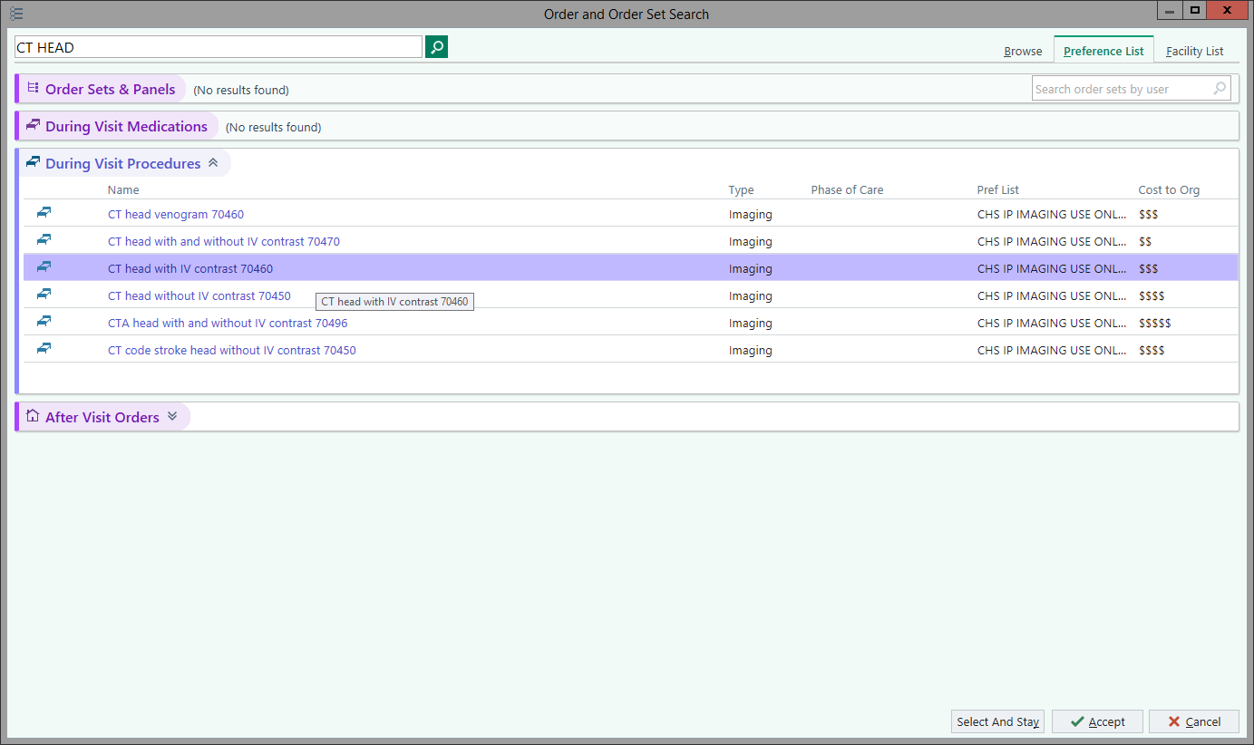

Scoring Feedback Presented to User

Once the **clinical indication** is selected, the user will see the Appropriate Use Criteria scoring for the scenario. The user will be presented with a list of alternative exams that may be more appropriate than the original order. The user is also presented with a link provided by CareSelect to read detailed rationale for the appropriateness scores provided.

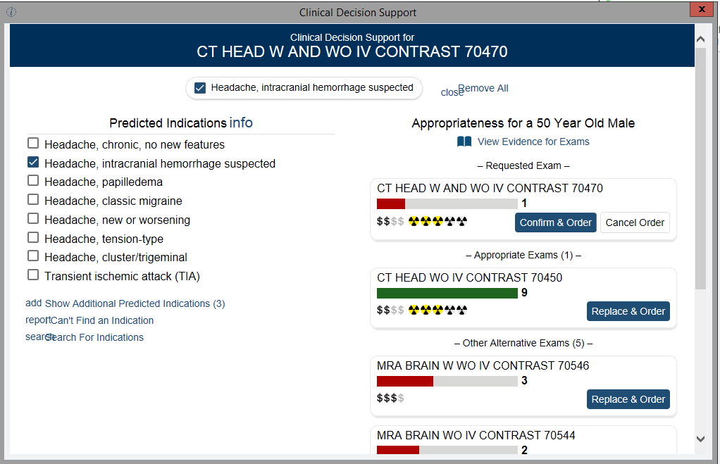

Placing an Alternate Order

If the user determines they will place an alternate order, they will need to select one of the alternate procedures offered in the BPA window. Upon selecting the alternate order by choosing “replace and order”, the original order will be removed, and the new order will be queued in the order composer.

